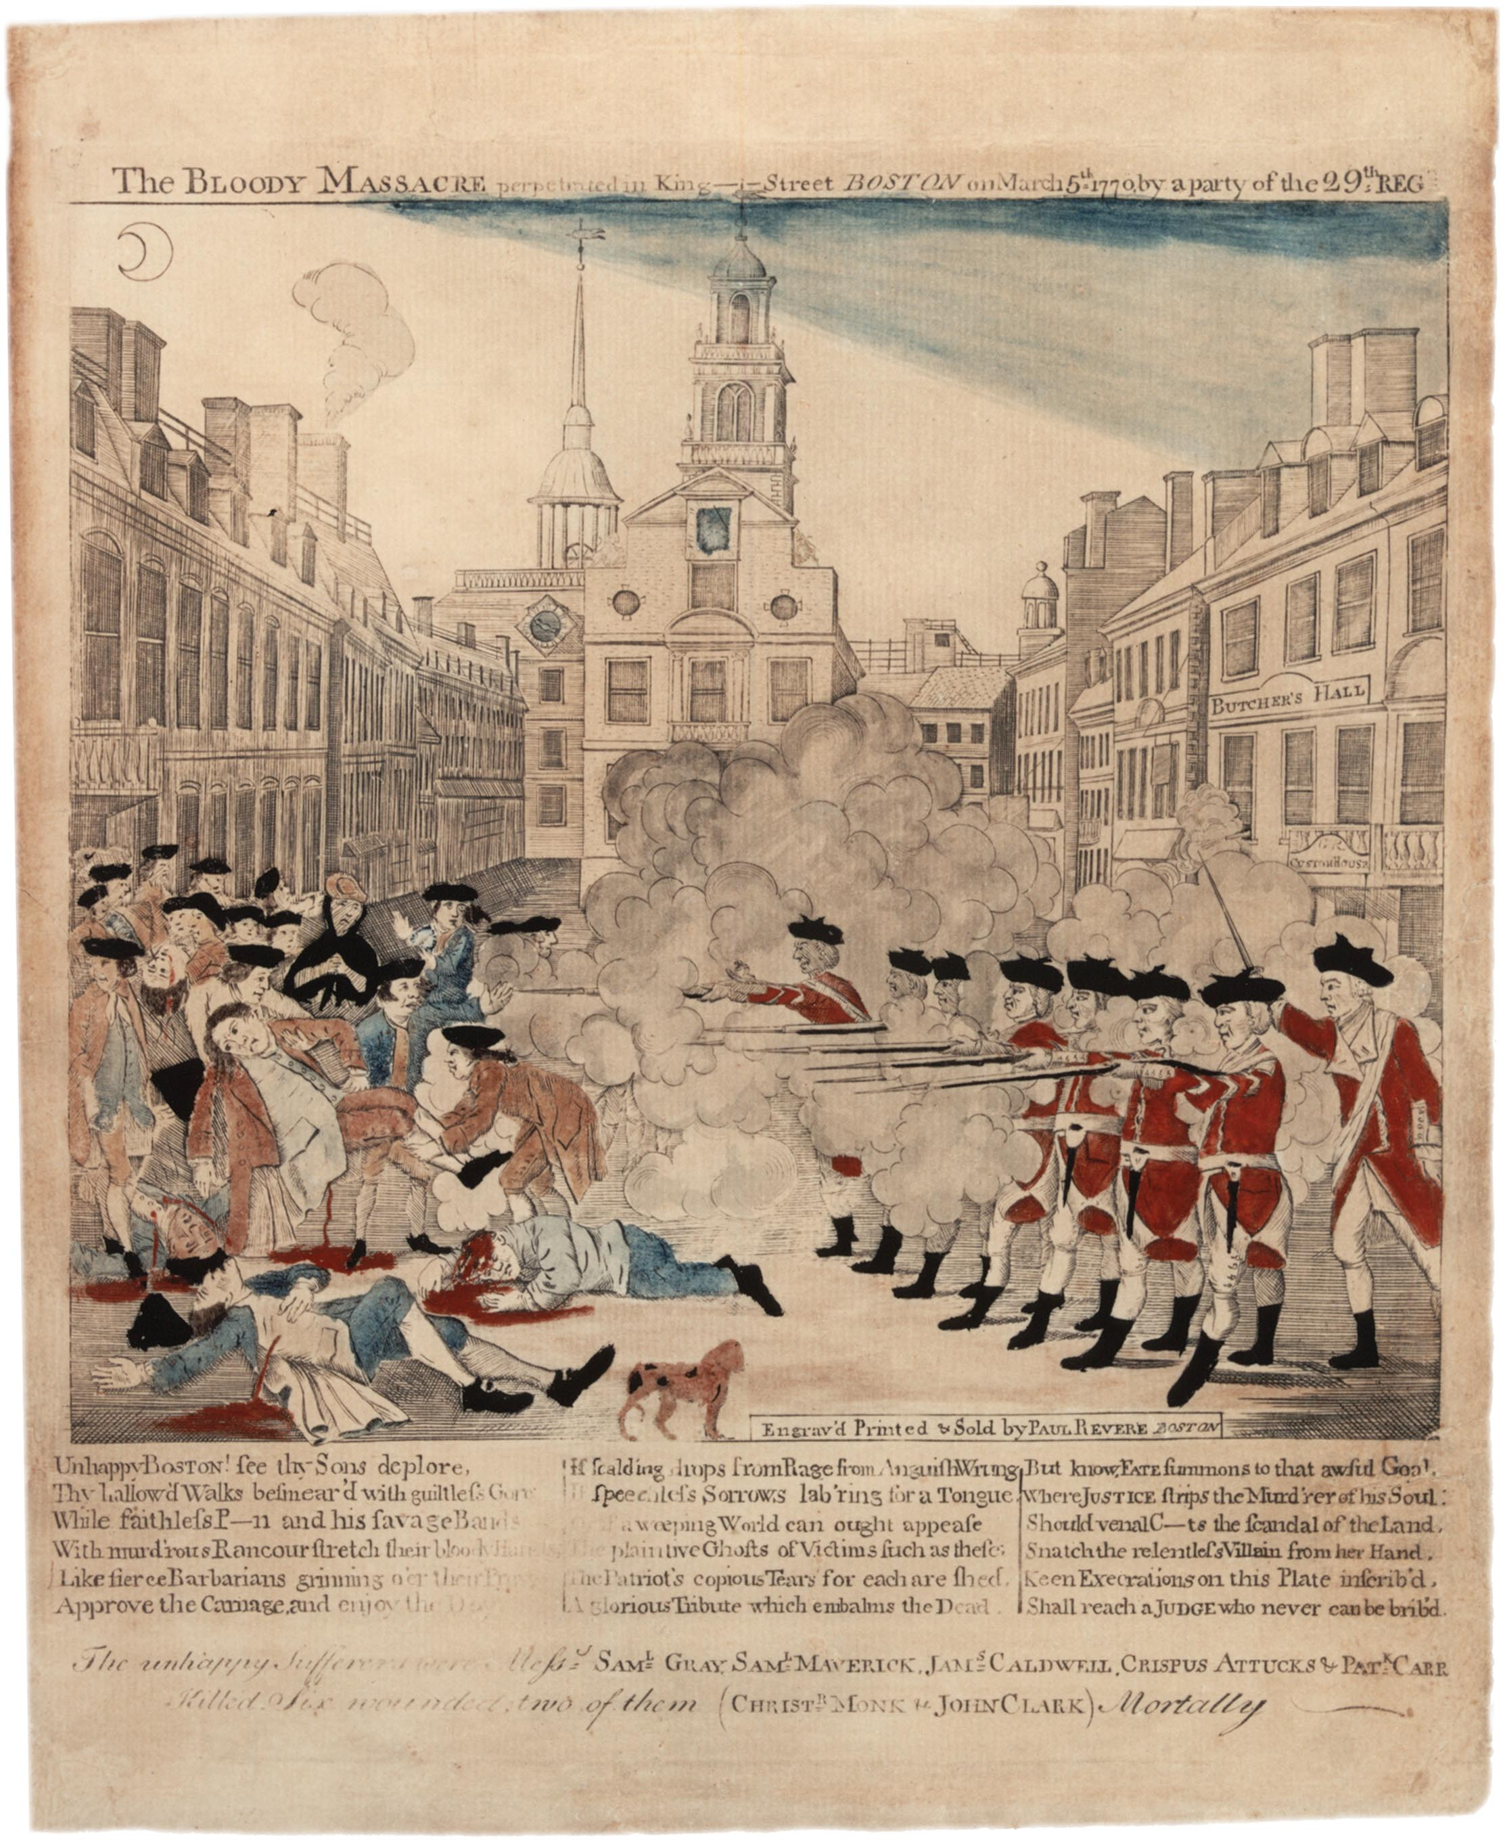
Primary Source Analysis: The Boston Massacre Engraving

The Boston Massacre Engraving was a hugely important piece of propaganda in pre-revolutionary America. Engraved by the well known early American figure, Paul Revere, famous for his midnight ride and such as anyone with a 3rd grade education in American history would be familiar with. The engraving and the sentiment towards the police action that it depicts was crucial in converting the unrest in the colonies into actual militia response. The piece is fundamentally misleading in its depiction, it depicts lines of fleeing civilians being brutally gunned down by the occupying British troops. Not to lessen the 5 casualties of the conflict, but the aggression started with the colonists throwing snowballs with rocks and other debris at the British, and the first shot was not ordered and there was no command given. Obviously, a nuanced depiction would not have been nearly as good of a rallying cry and for an image that will be disseminated vastly over the colonies, so certain things were left out or added. Interestingly, the engraving depicts a sniper under the Butcher’s Hall sign which could maybe indicate a third party or that the massacre was premeditated by the British with the man in Butcher’s Hall waiting for a reason to shoot. The woman standing with a mournful look directly in the center of the crowd is also an appeal to chivalry and paints the British army as barbarous and cruel. Matching the title of “Bloody Massacre” there is also lots of spilt blood depicted in the engraving. This sort of viscera would be enraging to those seeing the propaganda, to see printed everywhere the blood of your potential countrymen, potential as the colonies were not a country yet. Print media was essential at the time for seeding ideas within the public, outlined in the reading “No Standing Armies!” anti-army pamphlets seeded the ideas that inspired early colonial philosophy that opposed the large standing army presence in the US. Similarly, this engraving would greatly support that philosophy that suggested this power that the army has is being used to strip the colonists of their liberties, brutally and violently so. After having viewed this media,` the Quartering Act must have been even more enraging than if one was impartial to the army. One would not only have to be inconvenienced by hosting these people in your home, one would be forced to shelter the weapon that beats down on people similar to you. Importantly too, this act effects landowners, which are one of the most important people in defense of liberty according to the Whig philosophy of the time. Landowners, if armed and forming militias had the most capability to resist the colonial power of the army. On the topic of landowners too it is important to highlight how the colonists are depicted in the engraving, they are shown as dressed in nice clothing one may make the assumption that they were men of significance, owning land or being active in communal policy. While this may have been the case for some, the conflict was mainly among laborers and the army depicting the laborers as gentleman likely had influence on the landowners of the time. They could more easily identify with those being shot. The engraving was an effective piece of propaganda in swaying those with the greatest capability to resist British forces in the colonies.

